**C PROJECT  
20CSE1030 Zubin Shah**

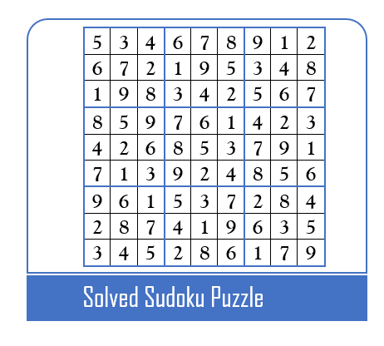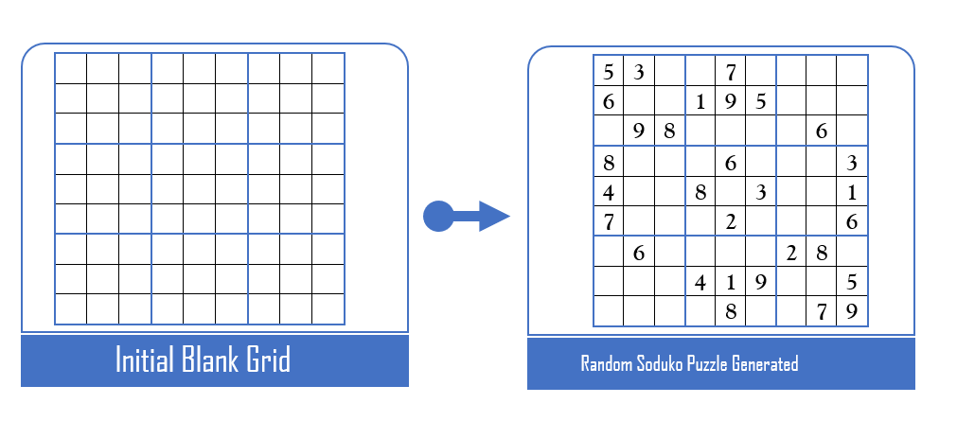**Project Title: Sudoku Puzzle Generator and Solver**

**This Project idea is about making a Sudoku puzzle game. The following options will be featured in our program.**

1. **Play**

**In this mode, the computer generates any random sudoku puzzle and let the user to input numbers in preferred boxes one by one. If an incorrect number is put, error message is displayed.**

1. **Solve**

**In this mode, the user sets any random sudoku puzzle and asks the computer to solve the sudoku puzzle.**

**Implementation: -**

* **Heavy usage of backtracking and recursion will be done in the implementation of this program.**

**Further Improvements Possible to the Project:**

* **Hard /Medium/ Easy difficulty level in the “Play” feature.**
* **Hint option in “Play” feature, wherein computer fills a random empty box as hint.**
* **Using file handling to track the lowest time consumed as score in solving a particular difficulty level.**
* **Using GTK+ library to provide a GUI for our program.**